
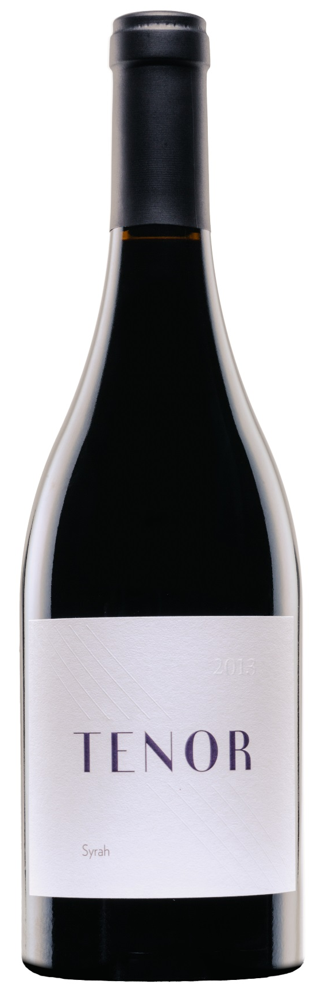
(91-93 points)- “A barrel sample, the 2013 Columbia Valley Syrah looks to be another beautiful wine from this estate. Inky colored, polished, fresh and full-bodied, with lots of dark plum, leafy herbs and mint on the nose, it shows the straight, focused nature of the vintage and should benefit from a year or two in the cellar after release.”
– Jeb Dunnuck, Wine Advocate
Vineyards: Lawrence & Stillwater Creek
Varieties: 100% Syrah
Drinkability: Now - 2026
Aging: 19 months in 36% new French oak
Alcohol: 15.5%
Production: 233 Cases

“Sweet smoke, perfectly ripe black currants, plum skin, black tea, and spice. This vintage is all about polish and precision with every note and detail in its perfect place. This is pure and polished with black fruit, tea spice and potpourri and a beautiful lifting finish. This is the beginning of a new era for Tenor where we aim to smooth everything out for the ultimate drinking pleasure”
– Aryn Morell, Winemaker

2013 Tenor Syrah

