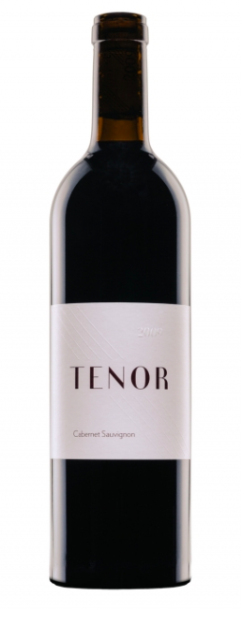

tenor

TRUE SOLOISTS:
100% SINGLE VARIETALS WASHINGTON STATE WINES

Since 2007, Tenor has produced seven- 100% single varietal wines each year. Our promise it to only bottle the varietals that showed best in the respective growing season. The results are the finest expression of a single varietal from a single growing season. Each vintage the varietals go through a rigorous evaluation so that each bottle is a complete expression of that grape, that place, and that moment in time.

2013 CABERNET SAUVIGNON

This 100% Cabernet Sauvignon proves that you can have big, bright, new world wines that are still perfectly balanced and composed. Tenor Cabernet is terrifically rich and fruit forward, but still incredibly supple and pleasurable to drink. On release, the wine presents with abundant ripe fruit, spice and freshness, characteristics that will continue to deepen through its prime (3-9 years), and beyond that, secondary characteristics of sage, plum skin and scorched earth will come forward.

Varietals: 100% Cabernet Sauvignon
Age: 60% new French oak for 21 months
Notes: Gorgeous sweet smoke, spice and cassis mixed with a plum and blueberry puree. Lightly roasted coffee and cocoa powder add to the nose with some air. The mouthfeel is absolutely stunning, with opulent textures, never ending fruit and flawless tannins. This is a purists Cabernet and it certainly will not disappoint.
TENOR, 16116 140th Place NE, Woodinville, WA 98072

